**User Manual**

**Table of Contents**

Installation3

Getting Started4

Main Menu4

Creating a new file5

**Overview of the scenario creator**6

Question Builder6

Add Text or Speech7

Display 8

Save, Test and Exit 8

**Audio Creator**9

**Trouble Shooting**10

**Contact Us**11

**Installation**

Below will the steps needed to download and start running the Braille Box software.

1. Navigate to <https://github.com/khallman97/2311-project> on your browser of choice.
2. Head to the bottom of the page where you will see Box that contains the final app version. In that area there will be a section that says Download instructions. Follow those instructions to download the file to a location on your computer.
3. Extract the zip file to the location of your choice. You can do this by right clicking and clicking the option, extract all, towards the top of the options.

Once extracted a new folder will appear. Once you see the folder open it up and run the enamel.jar file to begin using the app.

Also available in the folder will be other documentation regarding testing, design and requirements.

**Getting Started**

**Main Menu**

Now that you have downloaded the software and run it you will now see the main menu of the software. Figure [1] shows a diagram of the main menu as well as a small explanation of what each button does.

Main menu display
**New**: The new button when clicked will allow you to create a new file that can be read using the braille reader. Once clicked a new window will open. The shortcut to activate this command is Alt + N.

**Edit:** The edit button once clicked will open a file chooser where you can select a already made scenario file. It will then open up a new window with a all your previous information on the scenario file set up. The shortcut to the edit button is Alt + E.

**Run:** The run button has the function of running your scenario file. Clicking on it will open up a file choose where you can select the file to be run. The shortcut to this button is Alt + R

**Exit:** The exit button once clicked exits the application. The shortcut to this is Alt + X.

Figure Main Menu

**Creating a new file**

After clicking the new button, you can now begin to make a new scenario file. Scenario files follow a specific format in which you need to set the number of braille cells and the number of buttons you wish to have. These cells and buttons would be found on the testing unit. Below will be the steps required to start building a new file. A picture with what the file looks like can be found in figure [2].

1. Click on new in the main menu.
2. Start by naming the file and name you want. There is no restriction on the name.
3. Enter in the number of cells you want for your simulation. **The input to this must be an integer (whole number)**. You will be prompted if you don’t enter a whole number.
4. Enter the number of buttons you want for your simulation. **The input to this must be an integer (whole number)**. You will be prompted if you do not enter in a whole number.
5. Click on the save and continue button or you can use the hot key, Alt + S.

If at anytime you wish to not continue just press the exit button or Alt + X. After finishing and clicking save and continue and you will see a new window show up.

**Overview of the scenario creator**

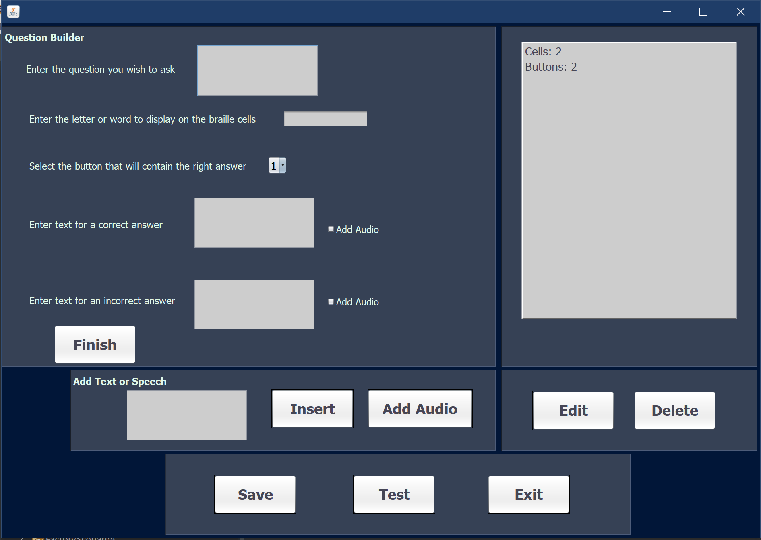Below in figure [3] is an image of the creator. You will also find an explanation of what everything does as well on the following page.

* **Question Builder**

The question builder is designed to help assist you in building the questions that the simulator will run. Below is the steps and description on how to build the question as well as what every option does. If you do not wish to add an option you may leave it blank, **however you must have something entered in the “Enter the letter or word to display…Option, otherwise the program will not add it to the file.**

* + In the first block next to “Enter the question you wish to ask”, you can enter text there in which you would like the user to hear. This is mainly for asking a question however such as “What is displayed below…”, but it is not a restriction to what you can type.
  + The block below you will find an area to set the braille cells to the desired outputs. You have the option to set it to a word like “hi” or you can set it to display different characters in the order you type it. For example if you want cell one to display A and cell two to display B you would type AB.
  + The next option you will see is a drop down box for selecting a button. The button sets the correct answer to be on that button click. The number of buttons will always be the same as whatever you have selected the buttons to be even if you edit it.
  + The next text area located next to “Enter text for a correct answer” is used for the message you wish to display if the user gets the correct answer. Next to it is also an option to add audio based off a pre-set noise of a correct sound. The audio for this can be found in the audio files folder and is called “correct.wav”.
  + The next text area located next to “Enter text for an incorrect answer”. It behaves the same way as if you entered in the text for the correct answer except this time for an incorrect answer. You also have an option to add audio for an incorrect answer in the form of a wrong noise. You can find the audio in the audio files folder and is called “wrong.wav”.
  + The last option is the button that says finish. Clicking this adds everything that you have written or selected from the above options to the project. You can access this by clicking the button or using the shortcut Alt + F.
* **Add Text or Speech**

In this area you have the option to add text or speech. This area is designed for you to enter whatever you want that may be outside of a question. If you enter text it will be read out in the actual simulation. Entering audio will be played during the simulation.

* + The first text box is where you enter what you would like to be said by the simulator. There is no condition on it. To enter the text into the file just click the insert button right next to where you entered the text.
  + The button that says audio will prompt ask you if you would like the record audio or add existing audio in a pop up.
* **Display**

The display is the panel that is located on the right hand of the screen. This displays everything that you have added to your file already. Clicking on something you have added allows you to edit or delete the line using the buttons below it. By default, you will not be able to click edit or delete unless you have selected an item.

* The edit button allows you to edit the selected text. Depending on what you have a selected a prompt will appear once you click edit. The prompt will allow you to edit what you have an make changed to that field.
* The delete button deletes the line and removes it from the file.
* **Save, Test and Exit**

The save test and exit button are designed to do what they say. Save will save the everything you have done to the file. Test will run the file through the simulation. Exit will exit the application.

**Audio Creator**

Clicking on the create new audio will open up the audio recorder. In this area you can record audio and add it to the file. Below in figure [4] is what the recorder will look like.

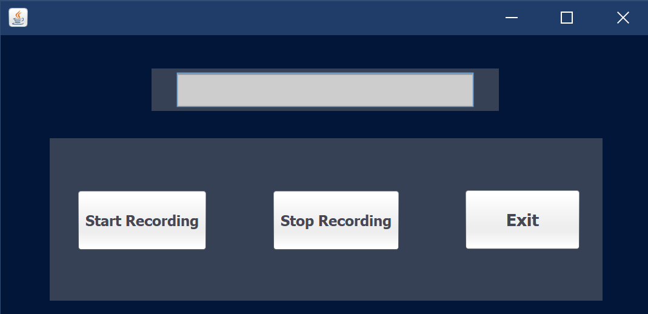

There are 3 buttons on the audio creator, start recording, stop recording and exit. The box at the top acts as a small display to tell you if you are recording the audio.

* The start recording button will prompt you to name the audio and then it will begin recording. You can check if you are recoding by looking at the small display above it.
* The stop recording button will end the current recording.
* The exit button will exit the recorder and add the audio to the file.

**Troubleshooting**

Here are some common errors or confusions answered:

|  |  |
| --- | --- |
| **Questions** | **Solutions** |
| The hot keys aren’t working | Try selecting outside of the text box or insure you are selected inside the window. |
| The audio recording is not working | Make sure you have a microphone plugged in and working. Feel free to use windows settings but right clicking the sound icon in the bottom right and going to recording settings. If it is working now restart the application. |
| On windows NVDA is not recognize some text | This one is tricky since the version of windows you are on can cause problems. Try going to Control Panel > Ease of Access Center > “Use the computer without a display” and going to the bottom and making sure “Java Access Bridge” is enabled |

**Contact Us:**

**Kyle Hallman |** [**khallman@my.yorku.ca**](mailto:khallman@my.yorku.ca)

**Thanks for downloading!**